**use case**



**use case specification**

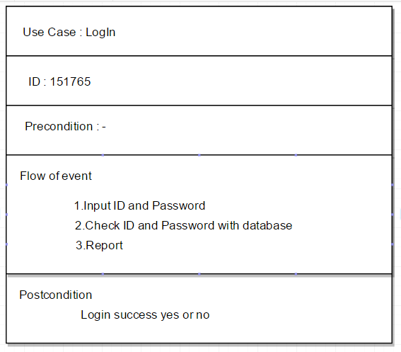

**business flow diagram**



**class diagram**



**sequence diagram**



**Communication Diagram**

